**Master-Node setup for Puppet v6 Server - Puppet Agent implementation**

**Infra on AWS Cloud**

1. **Master Node (Ubuntu)**
2. **Client-01 (Ubuntu)**
3. **Clinet-02 (Amazon Linux)**

**NOTE: Launch 3 Instances with t2.micro(All should run on default VPC with same subnet)**

**ON MASTER NODE (Ubuntu)**

* **sudo hostnamectl set-hostname puppetserver.ec2.internal**

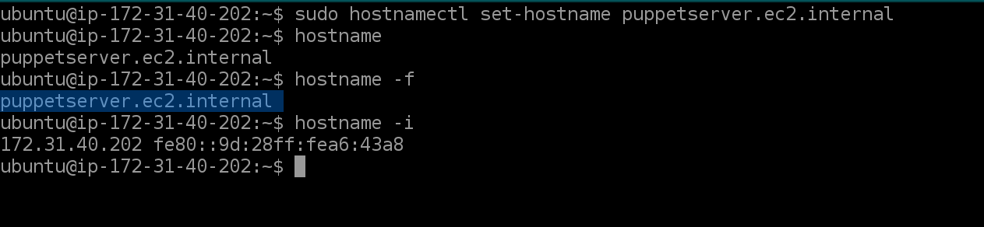

* **exec bash**
* **hostname –f** # Host DNS: puppetserver.ec2.internal
* **hostname –i** # Private IP: 172.31.40.202

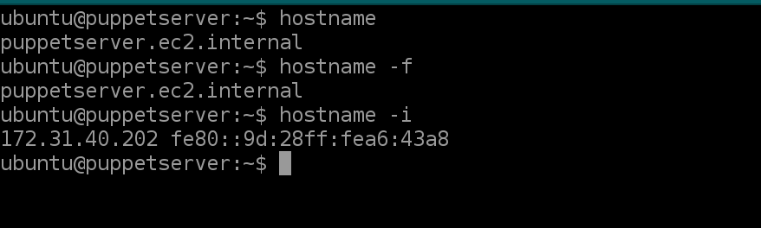

* **sudo nano /etc/hosts**

Add 172.31.40.202 puppetserver.ec2.internal puppet to the host file

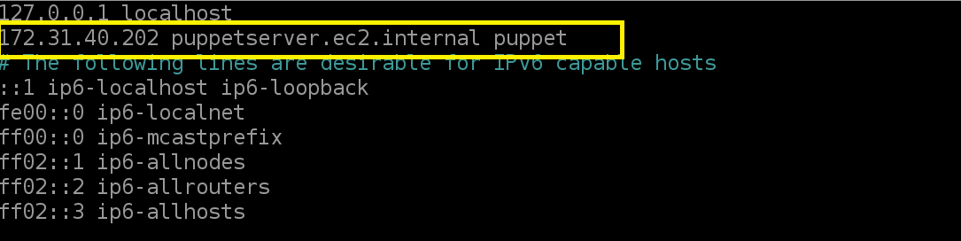

* **wget** [**https://apt.puppetlabs.com/puppet6-release-bionic.deb**](https://apt.puppetlabs.com/puppet6-release-bionic.deb)

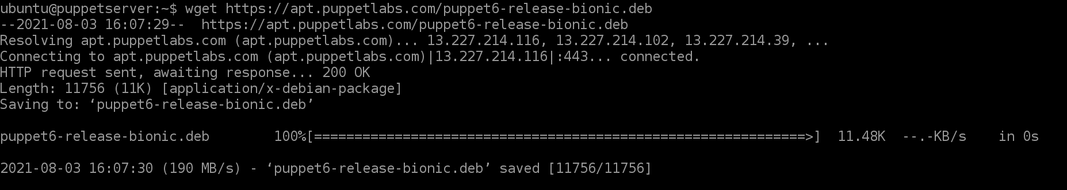

* **sudo dpkg -i puppet6-release-bionic.deb**

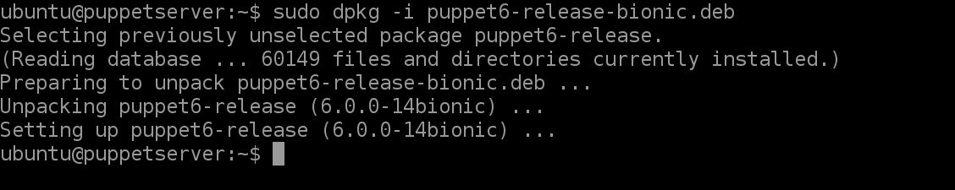

* **sudo apt update**

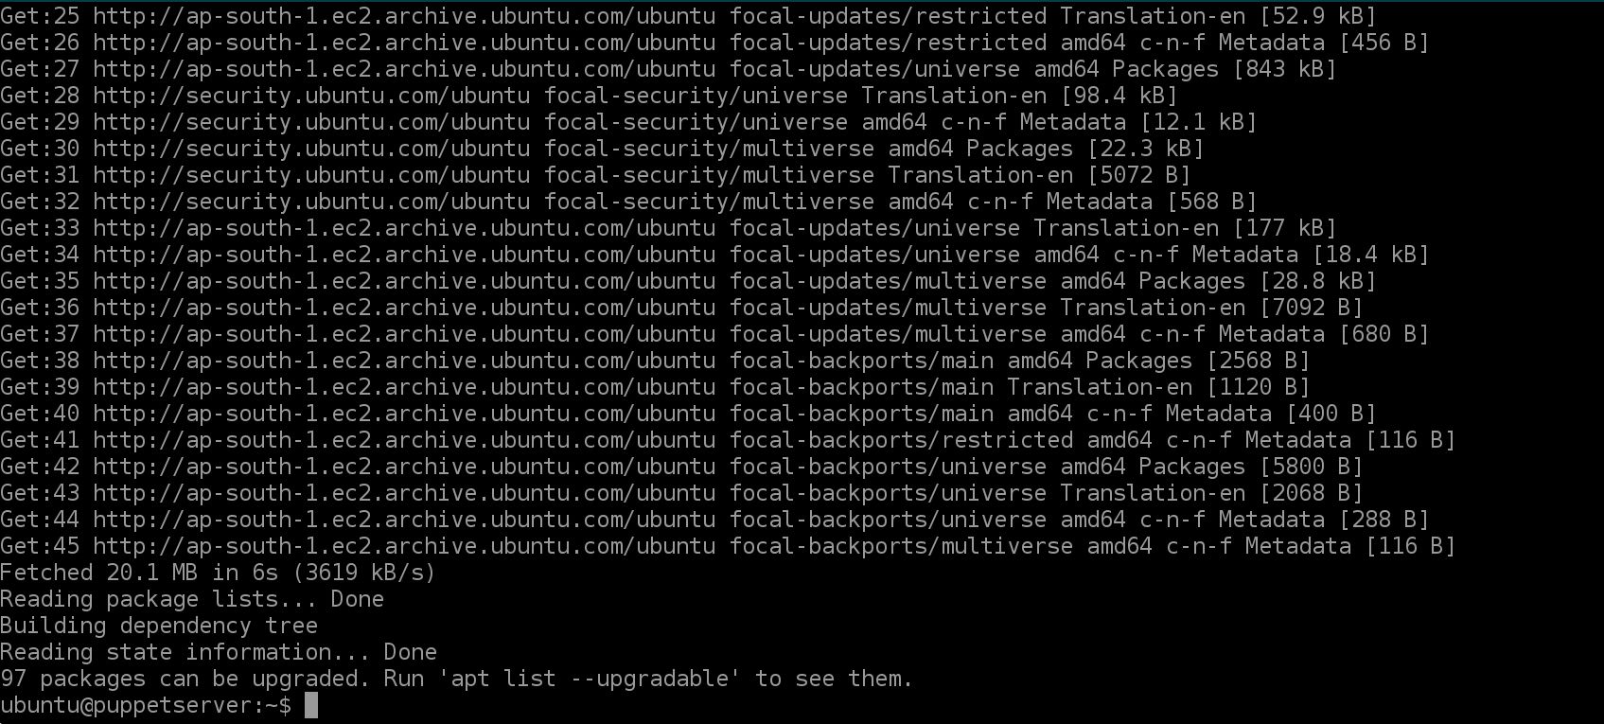

* **sudo apt-get install puppetserver**

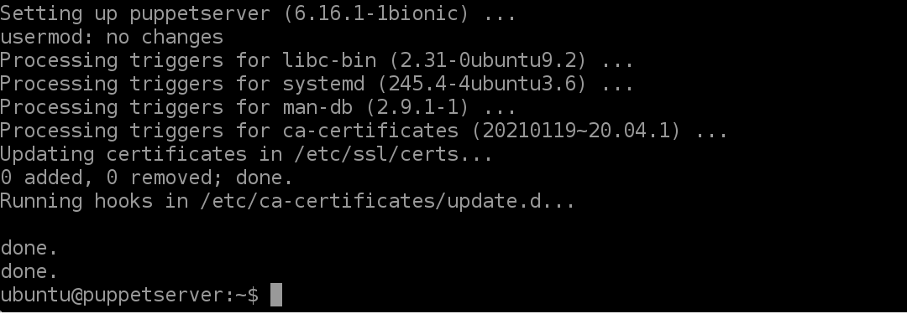

* **sudo nano /etc/default/puppetserver**

######**change memory or heap values** to **512m** instead of **2g** if memory is less on your server

JAVA_ARGS="-Xms512m -Xmx512m -Djruby.logger.class=com.puppetlabs.jruby_utils.jruby.Slf4jLogger"

===========================================

reboot  or continue if next command works    **## prefer reboot**

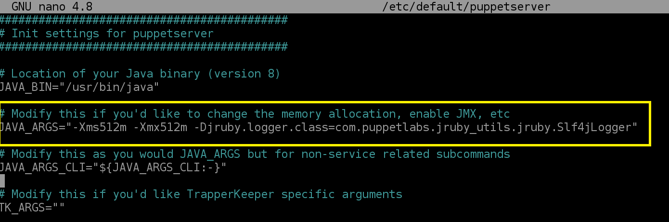

* **sudo –i (Change to ROOT for the next commands to run)**
* **puppetserver ca setup OR /opt/puppetlabs/bin/puppetserver ca setup**

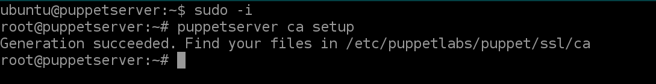

* **systemctl start puppetserver.service**

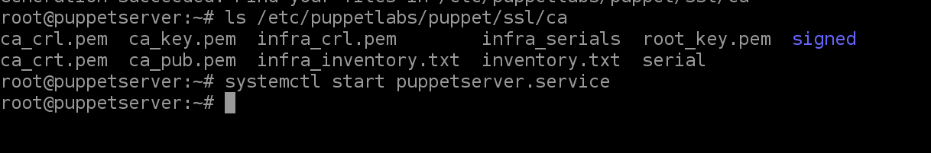

* **systemctl status puppetserver.service**

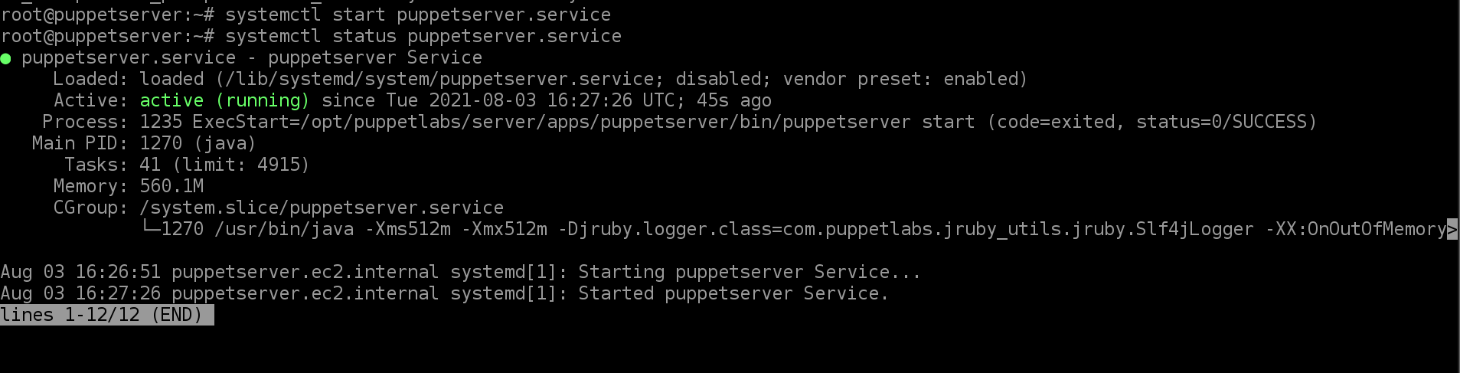

* **systemctl enable puppetserver**



**ON CLIENT-NODE 1 (**Ubuntu**)**

* **sudo hostnamectl set-hostname puppetagent1.ec2.internal**
* **excec bash**



* **hostname –f** # Host DNS: puppetagent1.ec2.internal
* **hostname –i** # Private IP: 172.31.39.156
* **sudo nano /etc/hosts**

Note: Same entry as on Server

Add 172.31.40.202 puppetserver.ec2.internal puppet to the host file

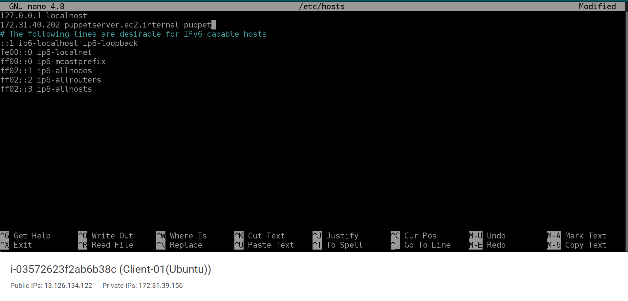

* **wget** [**https://apt.puppetlabs.com/puppet6-release-bionic.deb**](https://apt.puppetlabs.com/puppet6-release-bionic.deb)

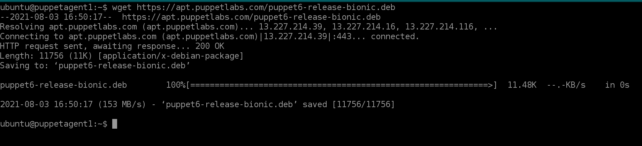

* **sudo dpkg -i puppet6-release-bionic.deb**

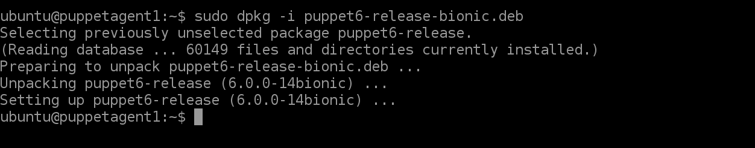

* **sudo apt update**

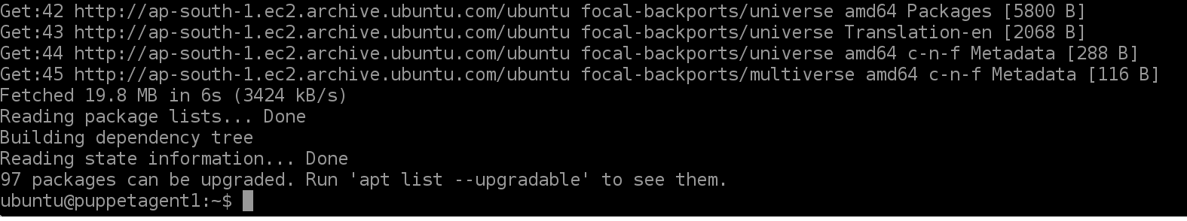

* **sudo apt-get install puppet-agent**

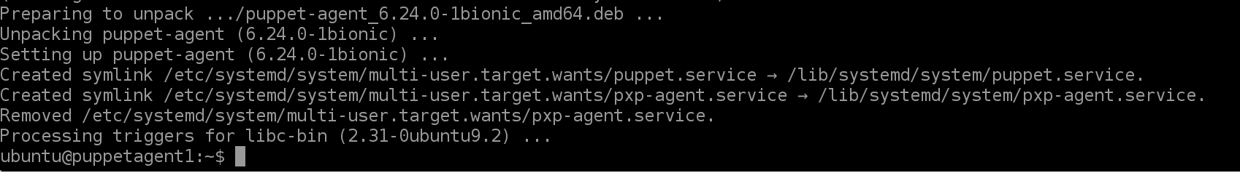

* **sudo nano /etc/puppetlabs/puppet/puppet.conf**

**add entry into the puppet.conf ( Connect to Server )**

[main]

server = puppetserver.ec2.internal

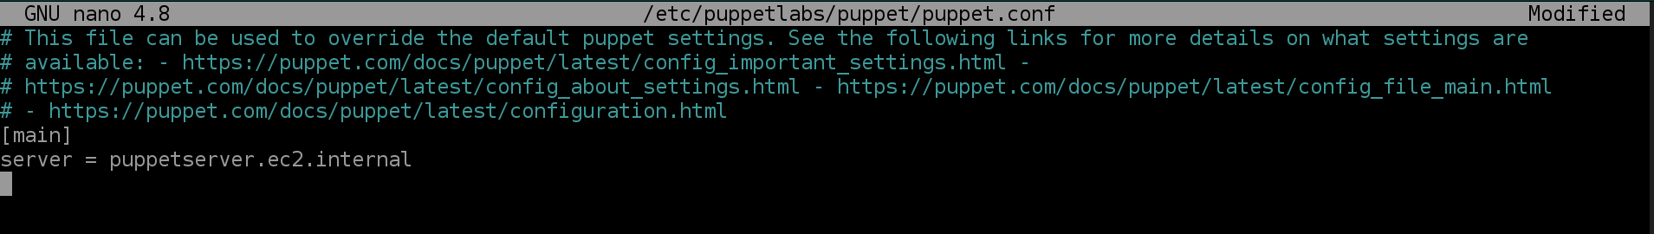

* **sudo systemctl restart puppet**
* **sudo systemctl status puppet**
* **sudo systemctl enable puppet**

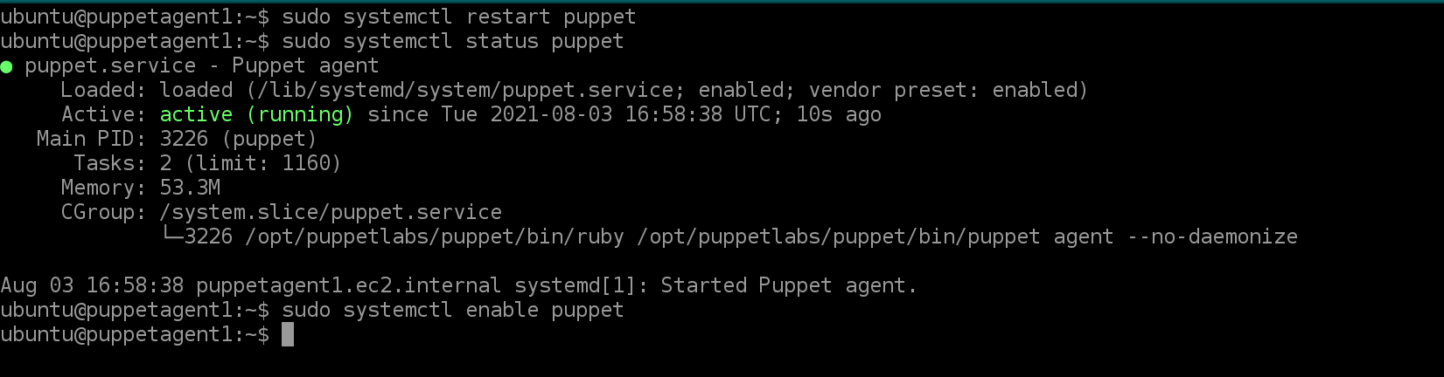

**GO TO THE SERVER**

* **sudo -i**
* **puppetserver ca list**
* **puppetserver ca list**
* **puppetserver ca list --all**
* **puppetserver ca sign --certname "puppetagent1.ec2.internal"**

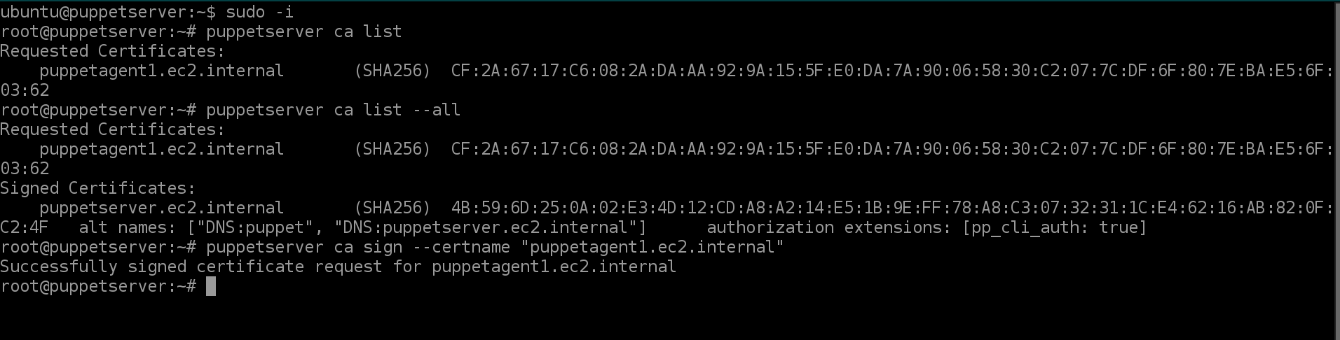

**ADDING CLIENT NODE-2 (**AMAZON LINUX**)**

* **sudo hostnamectl set-hostname puppetagent2.ec2.internal**
* **exec bash**

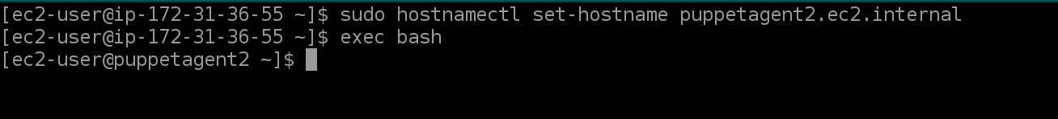

* **sudo nano /etc/hosts**

Add IP address of the server and hostname of the server

Add 172.31.40.202 puppetserver.ec2.internal puppet to the host file

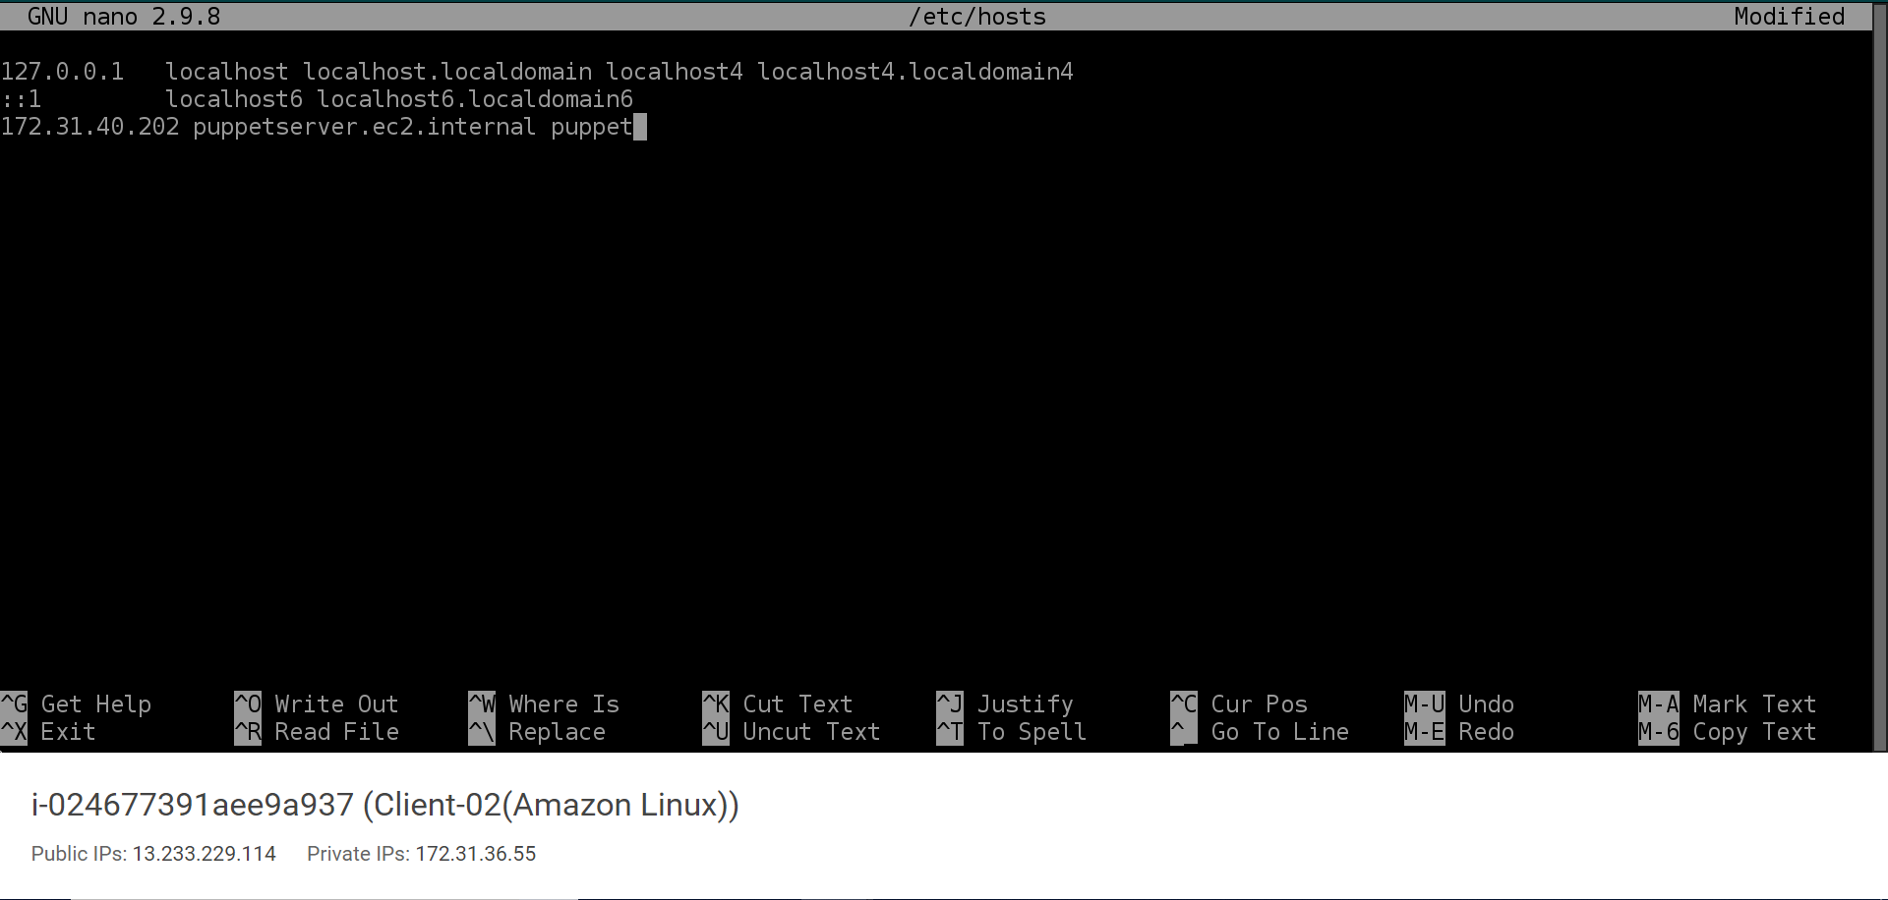

* **sudo rpm -Uvh** [**https://yum.puppet.com/puppet6-release-el-7.noarch.rpm**](https://yum.puppet.com/puppet6-release-el-7.noarch.rpm)

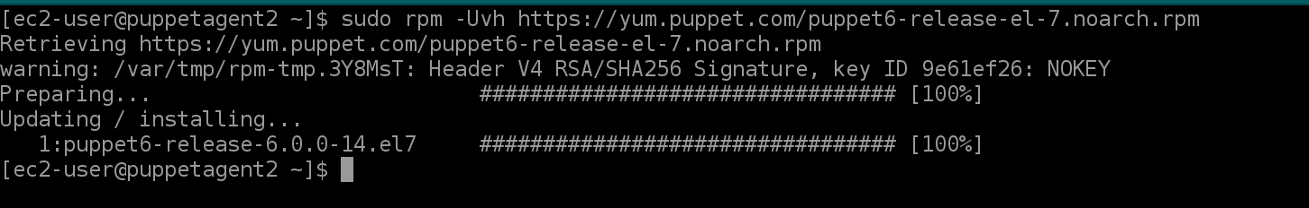

* **sudo yum repolist**

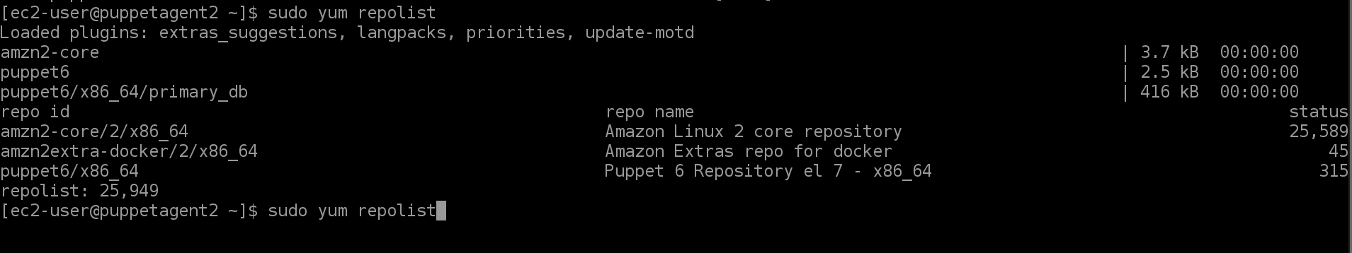

* **sudo yum install puppet-agent**

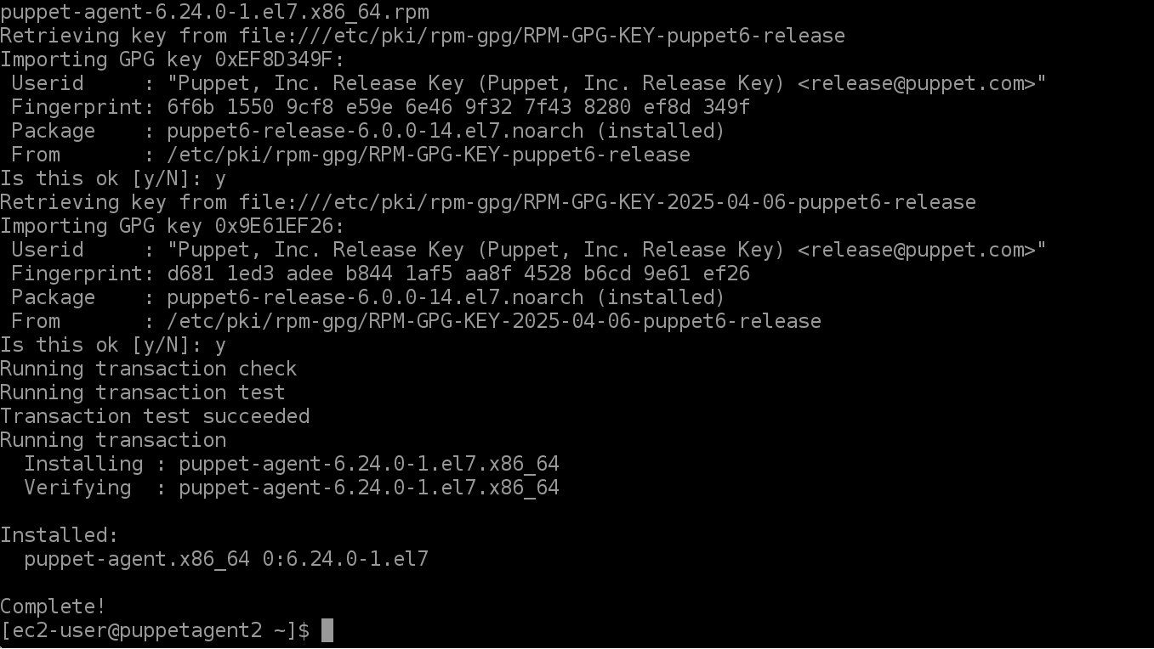

* **sudo nano /etc/puppetlabs/puppet/puppet.conf**

**add entry into the puppet.conf ( Connect to Server )**

[main]

server = puppetserver.ec2.internal

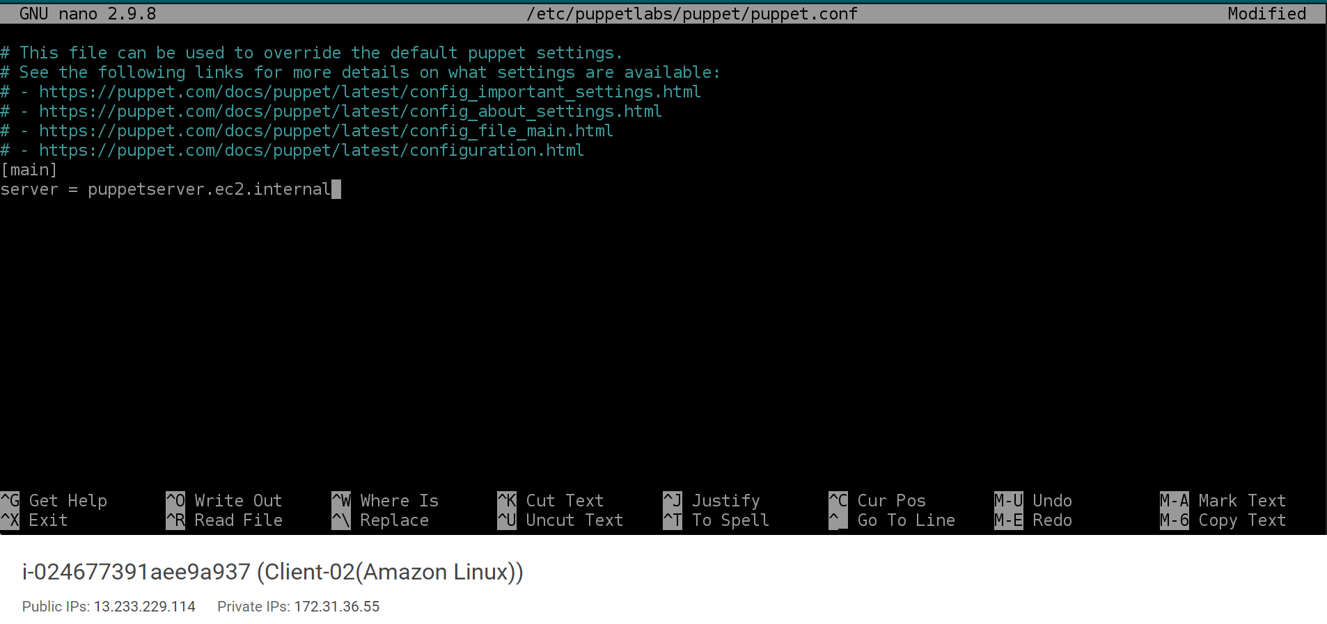

* **sudo systemctl start puppet**
* **sudo systemctl status puppet**
* **sudo systemctl enable puppet**

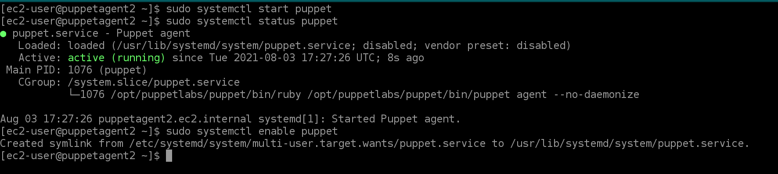

**GO TO THE SERVER**

* **sudo -i**
* **puppetserver ca list**
* **puppetserver ca list**
* **puppetserver ca list --all**
* **puppetserver ca sign --certname "puppetagent2.ec2.internal"**

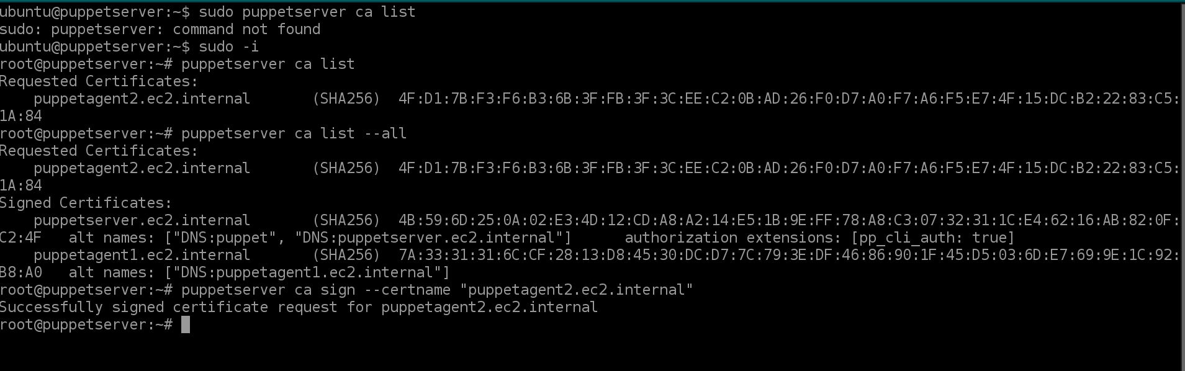

**TO CHECK THE CONFIGURED CLIENT NODES ON THE SERVER (MASTER) (Sample config. push to Client-1 and Client-2 nodes)**

* **nano /etc/puppetlabs/code/environments/production/manifests/site.pp**

node 'puppetagent1.ec2.internal' {

file { '/etc/motd':

ensure => present,

content => "This is NODE1"

}

}

node 'puppetagent2.ec2.internal' {

file { '/var/lib/update-motd/motd':

ensure => present,

content => "This is NODE2"

}

}

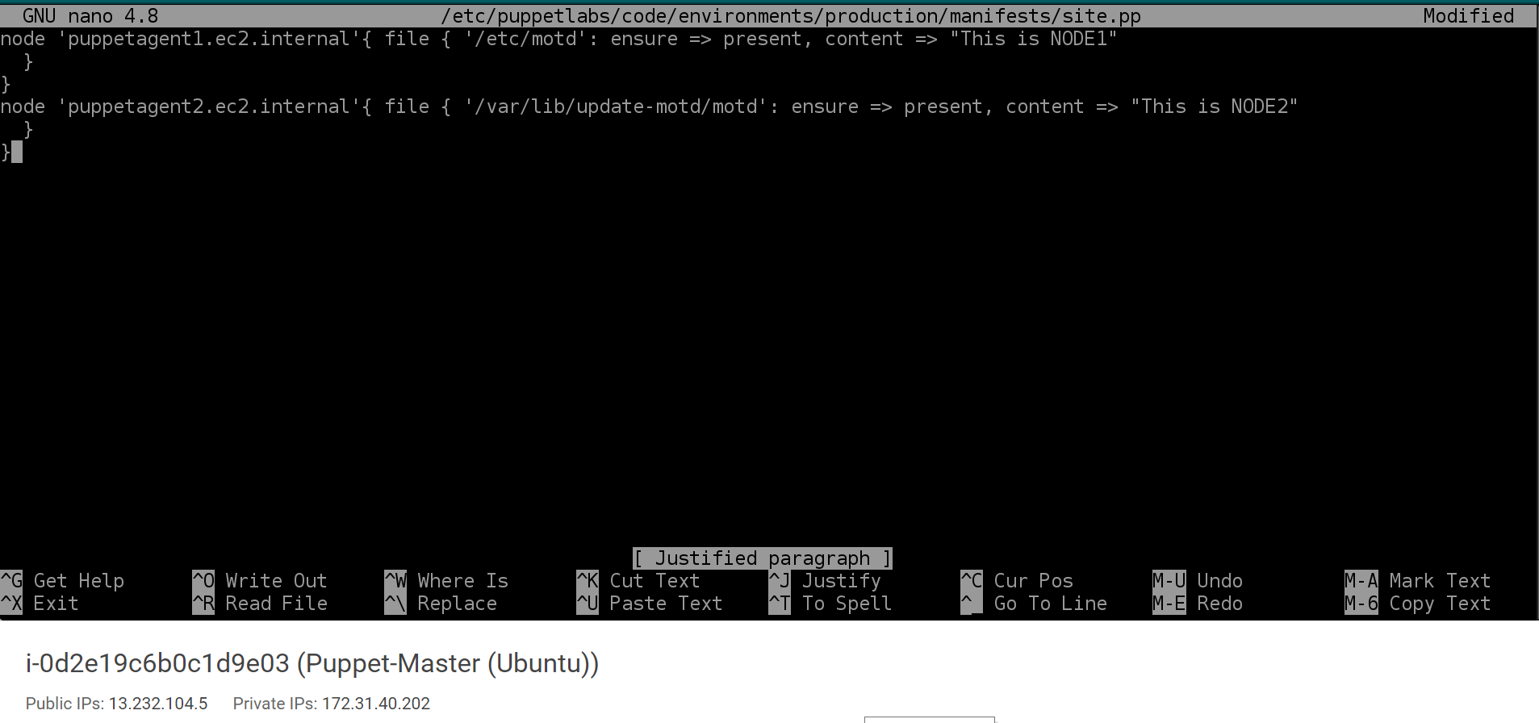

============================================

On clients login by root user

**sudo -i**

**puppet agent --test**

**OR**

**/opt/puppetlabs/bin/puppet agent --test**

==============================================

ON CLIENT-1

* **puppet agent –test**
* **cat /etc/motd**

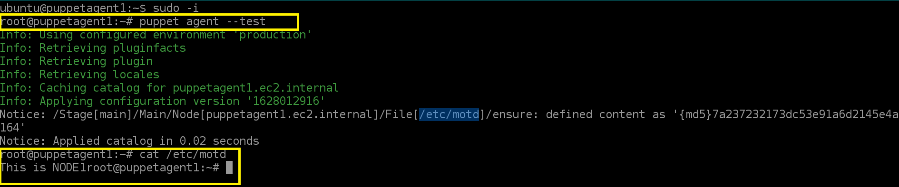

ON CLIENT-2

* **puppet agent –test**

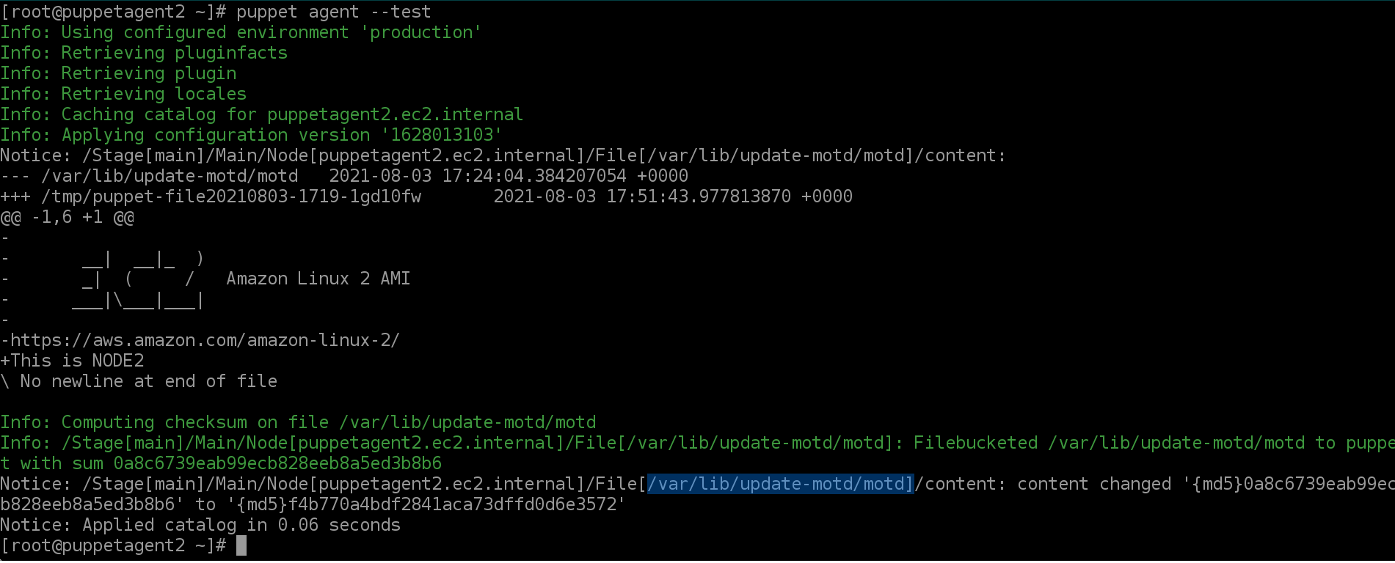

* **cat /var/lib/update-motd/motd**



**\*\*\*\*\*\* Congratulations Setup is successfully completed \*\*\*\*\*\***